CHAPTER 4

ΙΜΡLΕΜΕΝΤΑΤΙΟN

4.1 INPUT TO ACCELEROMETER (ADXL 335)

Different Hand gestures to make the robot move in specific directions are as follow:

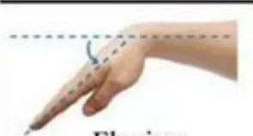

##### Flexion

Fig 5-1 Move Forward

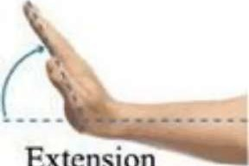

Extension

Move

Backward

Fig 5-2 Move Backward



Fig 5-3 Move Right

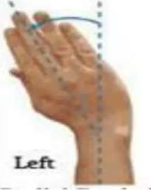

Fig 5-4 Move Left

The robot only moves when the accelerometer is moved in a specific direction. The valid movements are as follows:

|  |  |
| --- | --- |
| DIRECTION | ACCELEROMETER ORIENTATION |
| Forward |  |
| Bac war |  |
| Rig t |  |
| Left | -x |
| top | Rest |

Table 5-1 Accelerometer Orientation

The accelerometer records the hand movements in the X and Y directions only and outputs constant analog voltage levels. These voltages are fed to the comparator IC which compares it with the references voltages that we have set via variable resistors attached to the IC. The levels that we have set are 1.7V and 1.4V. Every voltage generated by the accelerometer is compared with these and an analog I or 0 signal is given out by the comparator IC.

Ref V—

Sig al

Out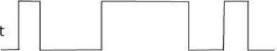

Fig 4-1 Input and Output of Comparator IC

There are total five conditions for this Gesture controlled Robot which are giving

below:

|  |  |
| --- | --- |
| Movement of | Input for Arduino from |
| hand | gesture |

SideD3 D2Direction

Stableo oStop

Tilt righto oTurn Right

Tilt lefto oTurn Left Tilt back 1 o o o Backward

Tilt front  o 1 o o Forward

This analog signal is the input to the encoder IC. The input to the encoder is parallel while the output is a serial coded waveform which is suitable for RF transmission. A push button is attached to pin 14 of this IC which is the Transmission Enable (TE) pin. The coded data will be passed onto the RF module only when the button is pressed. This button makes sure no data is transmitted unless we want to.

The RF transmitter modulates the input signal using Amplitude Shift Keying (ASK) modulation. It is the form of modulation that represents digital data as variations in the amplitude of a can-ier wave.

The following figure shows the modulated output of the RF module:

Carrier

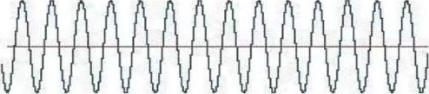

Modulating Wave (digital)

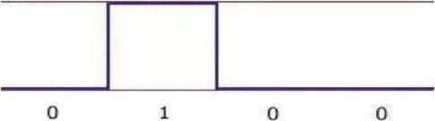

Modulated Result

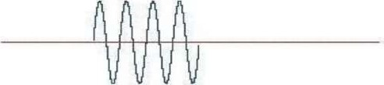

Fig 4-2 ASK Modulation

The RF modules works on the frequency of 315MHz. It means that the carrier frequency of the RF module is 315MHz. The RF module enables the user to control the robot wirelessly and with ease.

|  |  |
| --- | --- |
|  | AMBALIKA INSTITUTE OF MANAGEMENT OF TECHNOLOGY (COLLEGE CODE - 363) |

The schematic of transmitting end can be seen below:

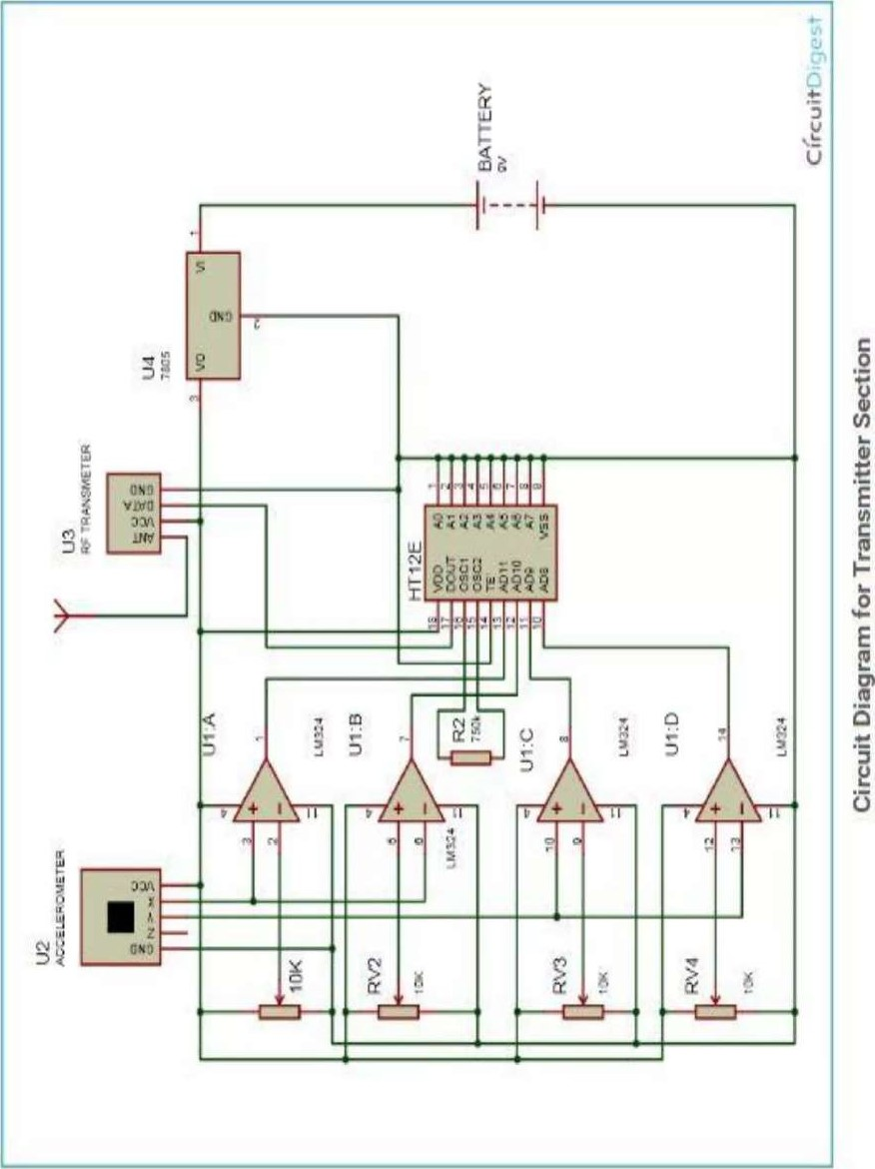

251

This transmitted signal is received by the RF receiver, demodulated and then passed onto the decoder IC. The decoder IC decodes the coded waveform and the original data bits are recovered. The input is a serial coded modulated waveform while the output is parallel. The pin 17 of the decoder IC is the Valid Transmission (VT) pin. A led can be connected to this pin which will indicate the status of the transmission. In the case of a successful transmission, the led will blink.

The parallel data from the encoder is fed to the port lof the microcontroller. This data is in the form of bits. The microcontroller reads these bits and takes decisions on the basis of these bits. What the microcontroller does is, it compares the input bits with the coded bits which are burnt into the program memory of the microcontroller and outputs on the basis of these bits. Port 2 of the microcontroller is used as the output port. Output bits from this port are forwarded to the motor driver IC which drives the motors in a special configuration based on the hand movements.

At a dead stop, a motor produces no voltage. If a voltage is applied and the motor begins to spin, it will act as a generator that will produce a voltage that opposes the external voltage applied to it. This is called Counter Electromotive Force (CEF) or Back Electromotive Force (Back EMF). If a load stops the motors from moving then the current may be high enough to burn out the motor coil windings. To prevent this, flyback diodes are used. They prevent the back emf from increasing and damaging the motors.

261

The schematic of receiving end can be seen below:

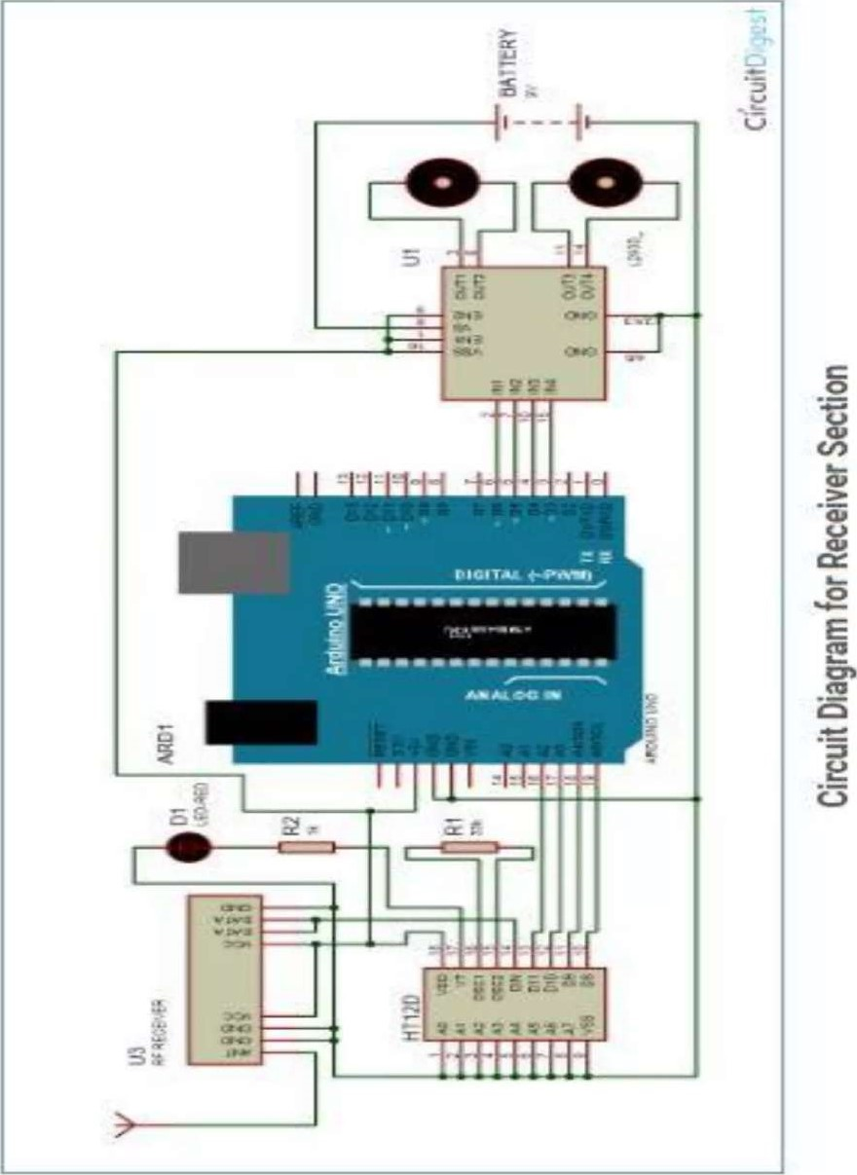

271

## 4.2 SIMULATION

We performed a simulation of our project in PROTEUS and the code was written in C language using KEIL MICROVISION. We wrote a code for the microcontroller to run DC motors using the H-Bridge IC (L293D). In the simulation we sent the relevant data to the Microcontroller (AT89C51) through switches. The Microcontroller processed the data and sent the information to the Actuator IC (L293D). The Actuator IC upon receiving information showed response by driving the DC motors. The simulation schematic is as follow:

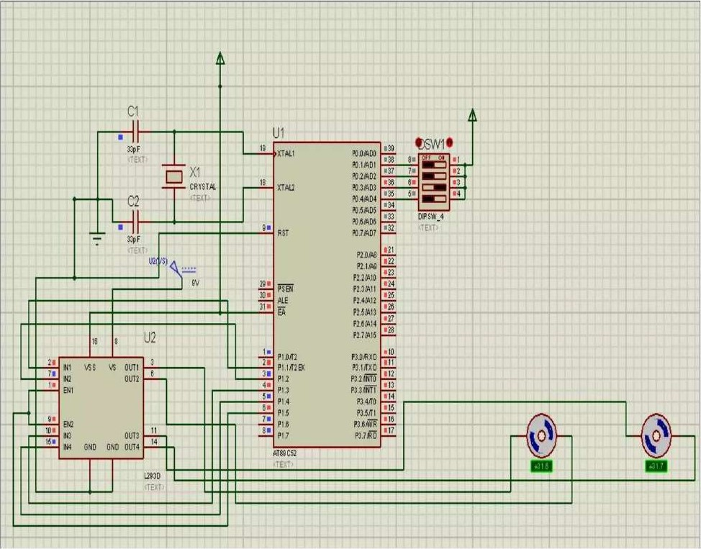

Figure 4-1 FYP-I Simulation

281

## 4.3 ADRUINO CODE

#define FD 16

#define BD 17

#define LD 18

#define RD 19

#define ml 1 3

#define ml 2 4

#define m21 5 #define m22 6 void forward()

digitalWrite(m11 , HIGH); digitalWrite(m12, LOW); digitalWrite(m21, HIGH); digitalWrite(m22, LOW);

void backward()

digitalWrite(m11, LOW); digitalWrite(m12, HIGH); digitalWrite(m21, LOW); digitalWrite(m22, HIGH);

void left()

digitalWrite(m11, HIGH); digitalWrite(m12, LOW); digitalWrite(m21, LOW); digitalWrite(m22, LOW);

void right()

digitalWrite(in11, LOW); digitalWrite(m12, LOW); digitalWrite(m21 , HIGH);

291

digitalWrite(m22, LOW);

void Stop()

digitalWrite(ml I , LOW); digitalWrite(m 12, LOW); digitalWrite(m21 , LOW); digitalWrite(m22, LOW);

void setup()

pinM0de(FD, INPUT); pinMode(BD, INPUT); pinM0de(LD, INPUT); pinM0de(RD, INPUT); pinM0de(m11, OUTPUT); pinM0de(m12, OUTPUT); pinM0de(m21, OUTPUT); pinM0de(m22, OUTPUT);

void loop()

int temp 1 —digitalRead(FD); int temp2=digitalRead(BD); int temp3=digitalRead(LD); int temp4=digitalRead(RD);

if(templ==l && temp2==0 && temp3==0 && temp4==0) backward(); else if(templ==() && temp2==1 && temp3—0 && temp4 forward(); else  && && && temp4—0) left(); else if(templ==() && temp2==0 && temp3 0 && temp4 right(); else Stop();

CHAPTER 5

## CONCLUSION, LIMITATIONS AND FUTURE

WORK

### 5.1 CONCLUSION

We achieved our objective without any hurdles i.e. the control of a robot using gestures. The robot is showing proper responses whenever we move our hand.

For controlling the robot remotely, Holteks' encoder-decoder pair (HT12E and HT12D) together with a 433MHz transmitter-receiver pair is used.

HT12E and HT12D are CMOS ICs with working voltage ranging from 2.4V to 12V. Encoder HT12E has eight address and another four address/data lines. The data set on these twelve lines (address and address/data lines) is serially transmitted when transmit-enable pin TE is taken low. The data output appears serially on DOUT pin.

The data is transmitted four times in succession. It consists of differing lengths of positive-going pulses for ' 1' and '0,' the pulsewidth for '0' being twice the pulse-width for ' l .' The frequency of these pulses may lie between 1.5 and 7 kHz depending on the resistor value between OSCI and OSC2 PINS.

Our finished product can be seen in the images below:

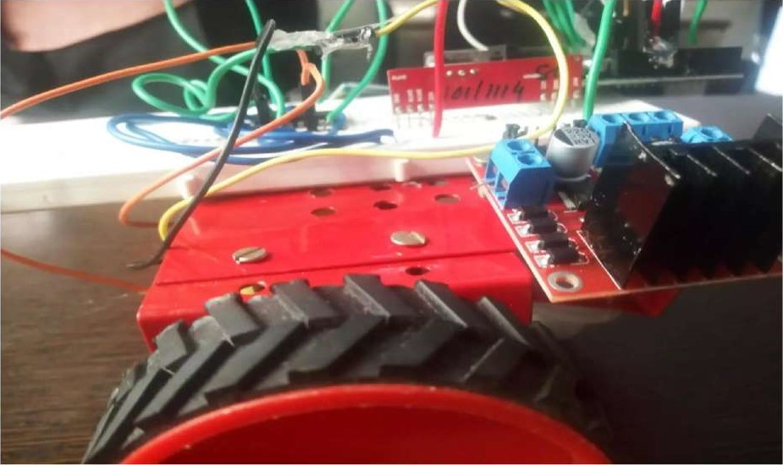

Figure 5-5 Robot-I

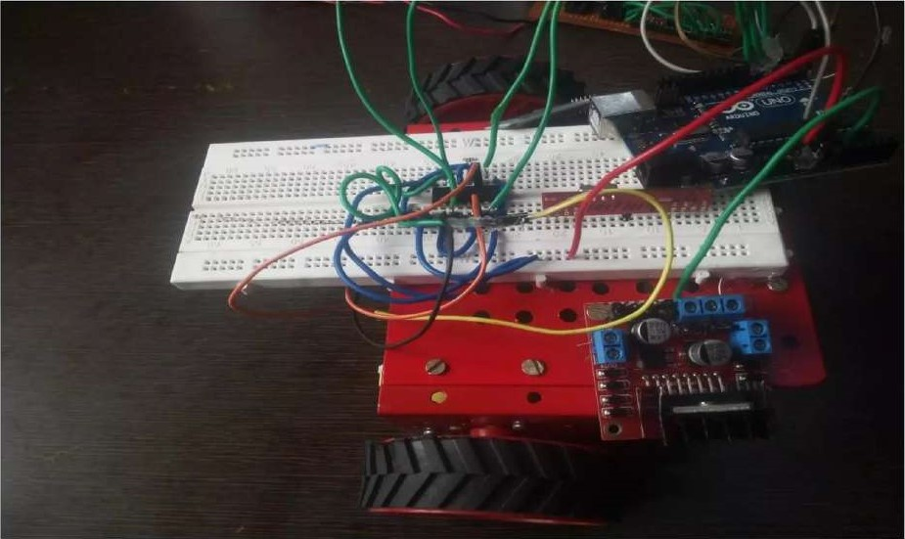

Figure5-6 Robot-2

331

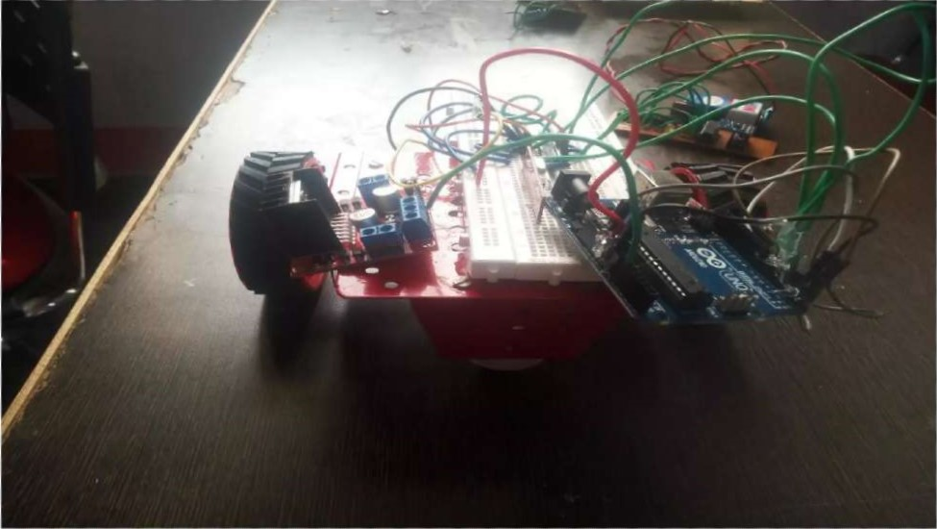

Figure 5-7 Robot Wheel

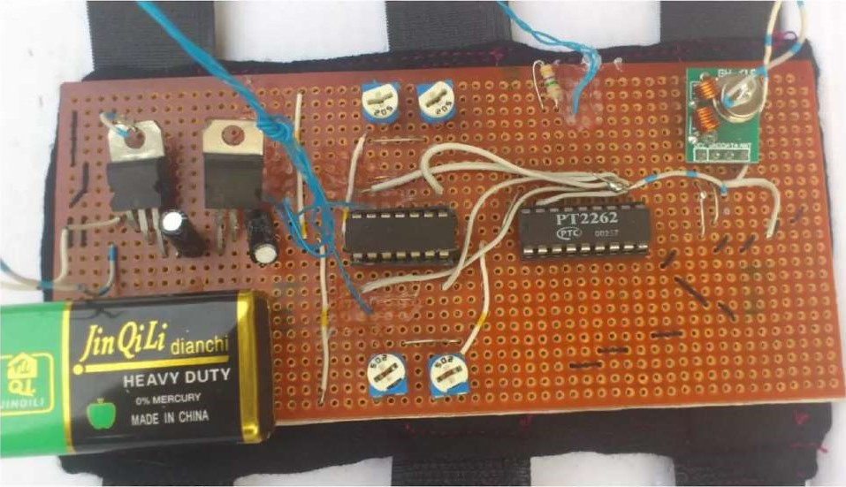

Figure 5-8 Transmitter Circuit

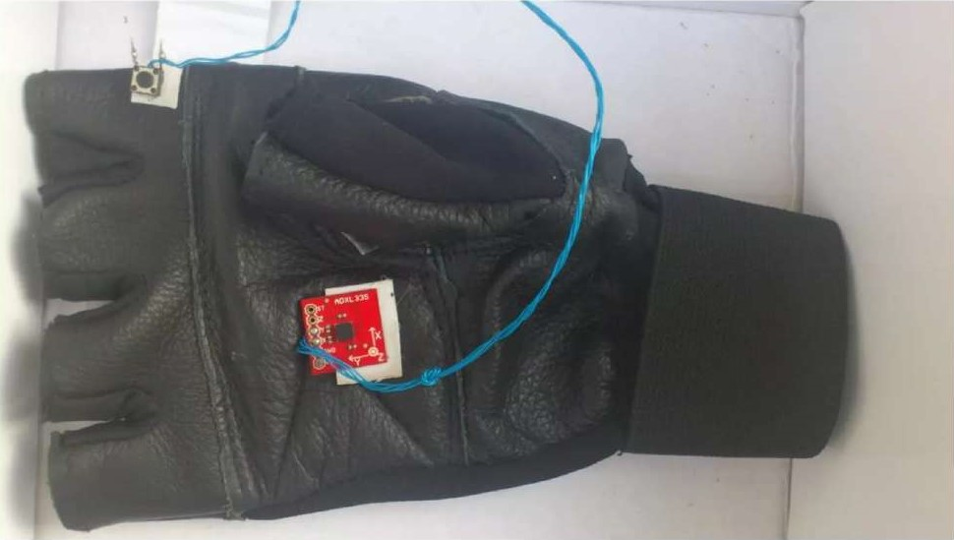

Figure 5-10 Hand Assembly

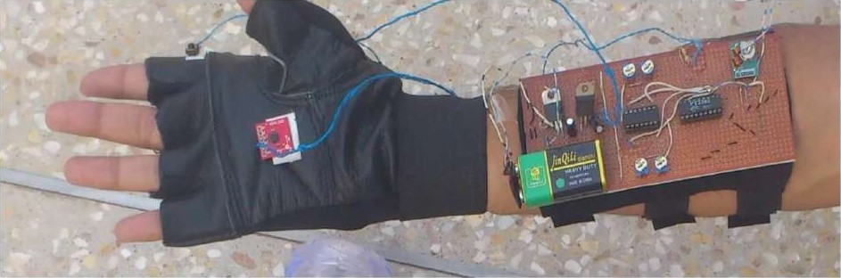

Figure 5-11 Robot with Hand Assembly

#### Disadvantages of the Current Gesture

The current gesture recognition system is a vision-based system which has many disadvantages, Including

* Costly solution
* Need high resolution cameras
* Highly sensitive to noise in image processing (lens aberrations)

##### Advantages of Touch less Gesture Recognition

The disadvantages of the vision-based recognition system have been overcome in the touch-less based Gesture Recognition system.

The advantages of the touch less sensing system are:

* Cheaper solution  Easy to develop
* Easy to maintain

 Easy to replace

* Easy to access  Touch-less

### 5.2 LIMITATIONS AND FUTURE WORK

* The on-board batteries occupy a lot of space and are also quite heavy. We can either use some alternate power source for the batteries or replace the current DC Motors with ones which require less power.
* Secondly, as we are using RF for wireless transmission, the range is quite limited; nearly 50-80m. This problem can be solved by utilizing a GSM module for wireless transmission. The GSM infrastructure is installed almost all over the world. GSM will not only provide wireless connectivity but also quite a large range.
* Thirdly, an on-board camera can be installed for monitoring the robot from faraway places. All we need is a wireless camera which will broadcast and a receiver module which will provide live streaming.